 **SAVEETHA SCHOOL OF ENGINEERING**

**SAVEETHA INSTITUTE OF MEDICAL AND TECHNICALSCIENCES**

**INSTITUTE OF COMPUTER SCIENCE ENGINEERING**

**MANAGEMENT INFORMATION SYSTEMS**

**Pathan Hussain Khan**

**192111400**

1. Develop a simple login page using service-based database in visual studio.

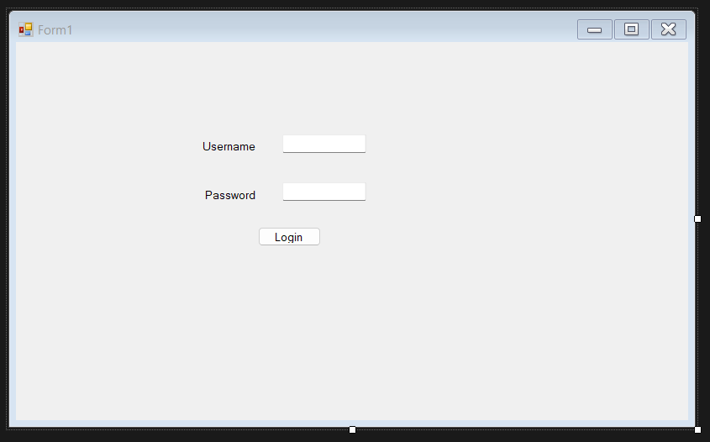

FRONTEND CODING

Imports System.Data.SqlClient

Imports System.Windows

Imports System.Windows.Forms.VisualStyles.VisualStyleElement

Public Class Form1

Dim con As New SqlConnection

Dim cmd As New SqlCommand

Dim dt As DataTable

Dim dr As SqlDataReader

Dim da As New SqlDataAdapter

Dim str As String

Private Sub Form1_Load(sender As Object, e As EventArgs) Handles MyBase.Load

'TODO: This line of code loads data into the 'Database1DataSet.login_view' table. You can move, or remove it, as needed.

Me.Login_viewTableAdapter.Fill(Me.Database1DataSet.login_view)

con.ConnectionString = "Data Source=(LocalDB)\MSSQLLocalDB;AttachDbFilename=D:\folders\MIS\web_login\web_login\Database1.mdf;Integrated Security=True"

End Sub

Private Overloads Sub Login(sender As Object, e As EventArgs) Handles Button1.Click

con.Open()

str = "Select * from login_view where Username='" & TextBox1.Text & "' and Password ='" & TextBox2.Text & "'"

cmd = New SqlCommand(str, con)

da = New SqlDataAdapter(cmd)

dt = New DataTable

da.Fill(dt)

If (dt.Rows.Count > 0) Then

MsgBox("Entry accessed")

Form2.Show()

Else

MsgBox("Invalid Username & Password")

End If

cmd.ExecuteNonQuery()

cmd.Dispose()

con.Close()

End Sub

End Class

BACKEND DATABASE SET :

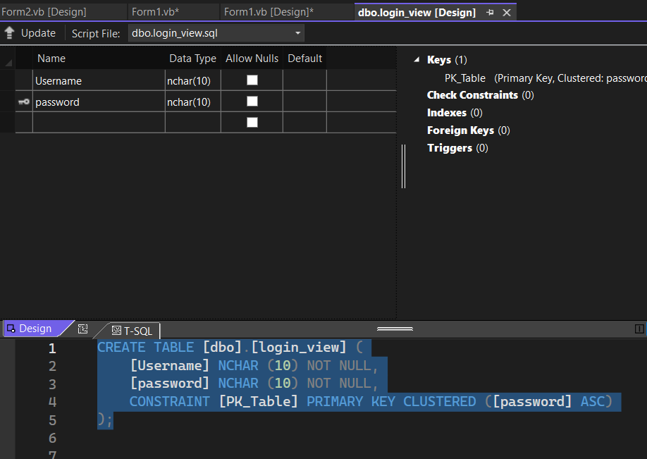

2. Develop a student information system using service-based database in visual studio.

FRONTEND :

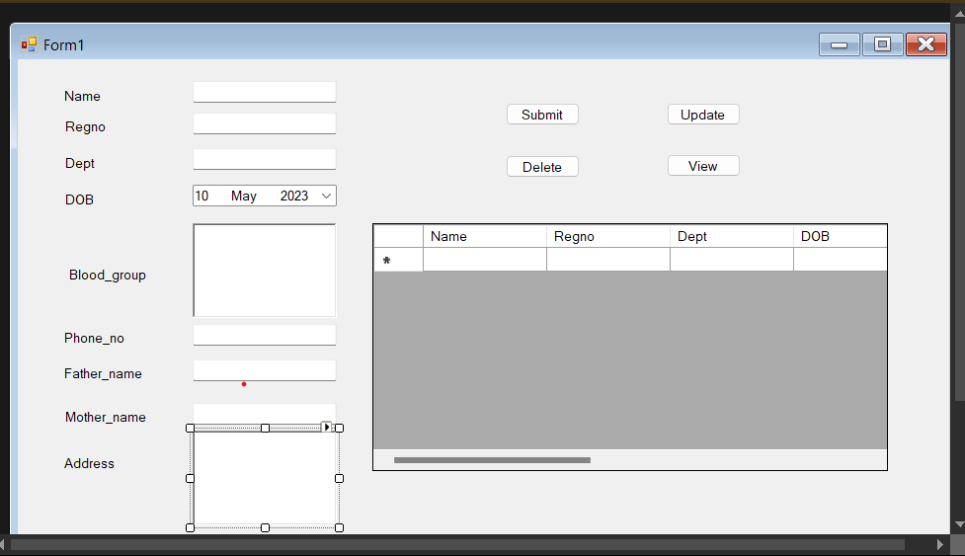

FRONTEND CODING:

Imports System.Data.SqlClient

Public Class Form1

Dim conn As New SqlConnection

Dim cmd As New SqlCommand

Dim dt As DataTable

Dim dr As SqlDataReader

Dim da As New SqlDataAdapter

Dim str As String

Private Sub Label8_Click(sender As Object, e As EventArgs) Handles Label8.Click

End Sub

Private Sub Form1_Load(sender As Object, e As EventArgs) Handles MyBase.Load

'TODO: This line of code loads data into the 'DetailsDataSet1.details' table. You can move, or remove it, as needed.

Me.DetailsTableAdapter.Fill(Me.DetailsDataSet1.details)

conn.ConnectionString = "Data Source=(LocalDB)\MSSQLLocalDB;AttachDbFilename=D:\folders\MIS\Program_1\Program_1\details.mdf;Integrated Security=True"

End Sub

Private Overloads Sub Insert(sender As Object, e As EventArgs) Handles Button1.Click

conn.Open()

str = "insert into details values('" & TextBox1.Text & "','" & TextBox2.Text & "','" & TextBox3.Text & "', '" & DateTimePicker1.Value.Date & "', '" & RichTextBox1.Text & "' , '" & TextBox4.Text & "','" & TextBox5.Text & "','" & TextBox6.Text & "' , '" & RichTextBox2.Text & "' )"

cmd = New SqlCommand(str, conn)

If cmd.ExecuteNonQuery() Then

MsgBox("successfully inserted")

End If

cmd.Dispose()

conn.Close()

End Sub

Private Overloads Sub Update(sender As Object, e As EventArgs) Handles Button2.Click

conn.Open()

str = "update details set Name='" & TextBox1.Text & "', Regno=" & TextBox2.Text & " where Regno =" & TextBox2.Text & ""

cmd = New SqlCommand(str, conn)

If cmd.ExecuteNonQuery() Then

MsgBox("successfully updated")

End If

cmd.Dispose()

conn.Close()

End Sub

Private Overloads Sub Delete(sender As Object, e As EventArgs) Handles Button3.Click

conn.Open()

str = "Delete from details where Regno ='" & TextBox2.Text & "'"

cmd = New SqlCommand(str, conn)

If cmd.ExecuteNonQuery() Then

MsgBox("successfully deleted")

End If

cmd.Dispose()

conn.Close()

End Sub

Private Overloads Sub View(sender As Object, e As EventArgs) Handles Button4.Click

DataGridView1.Visible = True

conn.Open()

str = "select * from details"

cmd = New SqlCommand(str, conn)

da = New SqlDataAdapter(cmd)

dt = New DataTable

da.Fill(dt)

DataGridView1.DataSource = dt

cmd.Dispose()

conn.Close()

End Sub

End Class

BACKEND DATABASE :

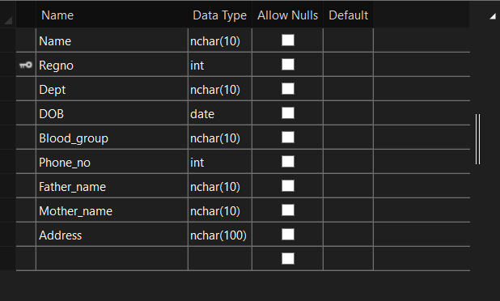

BACKEND SQL CODING :

CREATE TABLE [dbo].[details] (

[Name] NCHAR (10) NOT NULL,

[Regno] INT NOT NULL,

[Dept] NCHAR (10) NOT NULL,

[DOB] DATE NOT NULL,

[Blood_group] NCHAR (10) NOT NULL,

[Phone_no] INT NOT NULL,

[Father_name] NCHAR (10) NOT NULL,

[Mother_name] NCHAR (10) NOT NULL,

[Address] NCHAR (100) NOT NULL,

CONSTRAINT [PK_Table] PRIMARY KEY CLUSTERED ([Regno] ASC)

);